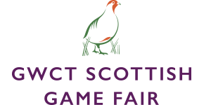
Exhibitor Factsheet
Please complete and return to charlotte.peters@stableevents.org as soon as possible
The information you provide will be used for marketing purposes for The Scottish Game Fair 2025. Please also provide the following:
- Brand logo
- 2 - 4 high-res product images illustrating exhibiting products
- If available, video footage showcasing your products and brand

Exhibitor Name

Website

Social Media Handles

Marketing Contact

Company Profile Summary:

New products exhibiting at The Scottish Game Fair
Details of any other products you are exhibiting at The Scottish Game Fair

Please confirm you consent to the use of the information included on this fact sheet for PR purposes | Yes / No

Any additional information:

